CREATE TABLE students (
student_id INT AUTO_INCREMENT PRIMARY KEY,
student_number VARCHAR(50) UNIQUE NOT NULL,
first_name VARCHAR(100) NOT NULL,
last_name VARCHAR(100) NOT NULL,
course VARCHAR(100),
year_level INT,
contact_number VARCHAR(20),
email VARCHAR(100),
created_at TIMESTAMP DEFAULT CURRENT_TIMESTAMP
);

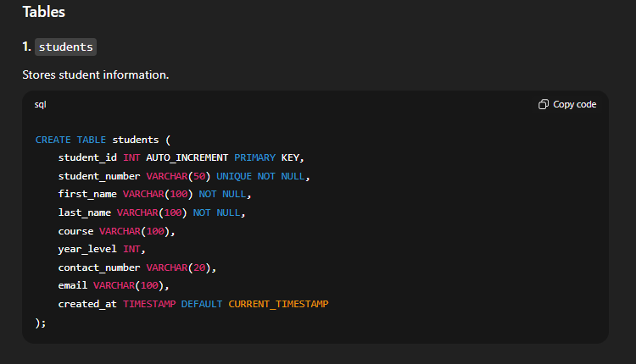

CREATE TABLE vehicles (
vehicle_id INT AUTO_INCREMENT PRIMARY KEY,
student_id INT NOT NULL,
plate_number VARCHAR(20) UNIQUE NOT NULL,
vehicle_type ENUM('Car', 'Motorcycle', 'Bicycle', 'Other') NOT NULL,
brand VARCHAR(100),
color VARCHAR(50),
registered_date DATE,
FOREIGN KEY (student_id) REFERENCES students(student_id) ON DELETE CASCADE
);
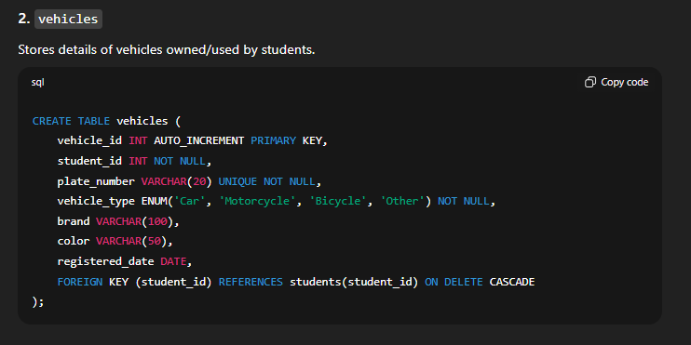

CREATE TABLE vehicle_logs (
log_id INT AUTO_INCREMENT PRIMARY KEY,
vehicle_id INT NOT NULL,
entry_time DATETIME DEFAULT CURRENT_TIMESTAMP,
exit_time DATETIME,
location VARCHAR(100),
status ENUM('In', 'Out') DEFAULT 'In',
FOREIGN KEY (vehicle_id) REFERENCES vehicles(vehicle_id) ON DELETE CASCADE
);

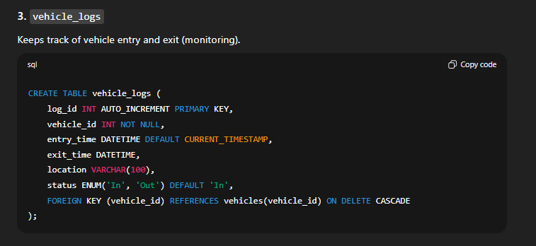

CREATE TABLE guards (
guard_id INT AUTO_INCREMENT PRIMARY KEY,
guard_name VARCHAR(100) NOT NULL,
contact_number VARCHAR(20),
shift ENUM('Morning', 'Afternoon', 'Night')
);
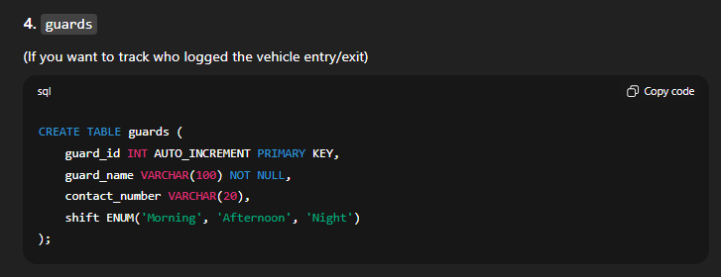

CREATE TABLE vehicle_monitoring (
monitoring_id INT AUTO_INCREMENT PRIMARY KEY,
log_id INT NOT NULL,
guard_id INT NOT NULL,
action_time TIMESTAMP DEFAULT CURRENT_TIMESTAMP,
remarks VARCHAR(255),
FOREIGN KEY (log_id) REFERENCES vehicle_logs(log_id) ON DELETE CASCADE,
FOREIGN KEY (guard_id) REFERENCES guards(guard_id) ON DELETE CASCADE
);
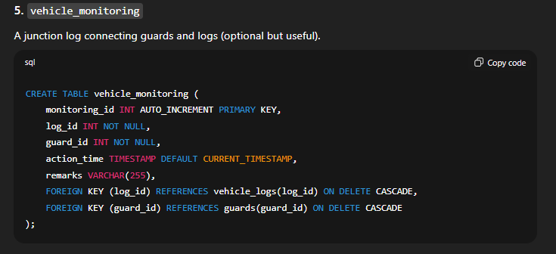

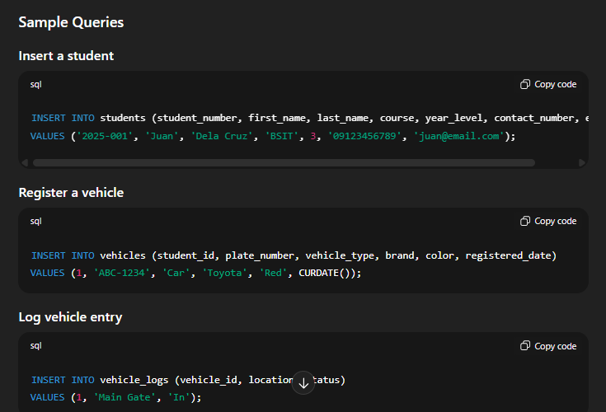
INSERT INTO students (student_number, first_name, last_name, course, year_level, contact_number, email)
VALUES ('2025-001', 'Juan', 'Dela Cruz', 'BSIT', 3, '09123456789', 'juan@email.com');

INSERT INTO vehicles (student_id, plate_number, vehicle_type, brand, color, registered_date)
VALUES (1, 'ABC-1234', 'Car', 'Toyota', 'Red', CURDATE());

INSERT INTO vehicle_logs (vehicle_id, location, status)
VALUES (1, 'Main Gate', 'In');

UPDATE vehicle_logs
SET exit_time = NOW(), status = 'Out'
WHERE log_id = 1;

